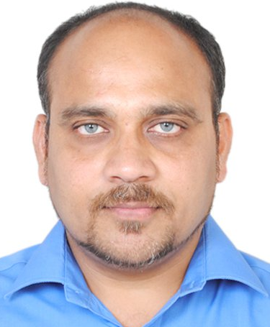
NAGARAJU VAIDYA
: +91-8880566511 / +91-9980523923
: mycareer.vaidya@gmail.com / nagraj.vaidya@gmail.com
: 212, 8th Main, HRBR Layout, 1st Block, Kalyannagar, Bangalore – 560043, Karnataka
LinkedIn: Yes
Seeking assignments in Software Testing / Training with an organization of repute preferably in IT industry
Location Preference: Hyderabad / Bangalore / Mumbai

PROFILE SNAPSHOT
- 12.5 years of experience in Software Testing and Training
- Conversant with the concepts of test management activities i.e.:
- Effort estimation, risk analysis to quality management in adherence to international guidelines and norms.
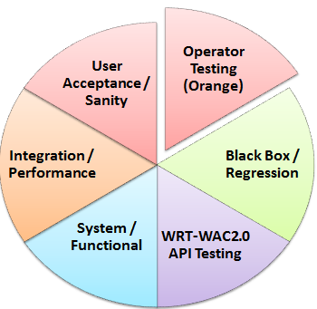
- Development of test strategies including creation of test scripts, test cases, execution of testing procedures and tracking of defects using various tools.
- Engaged in conducting manual & automated testing and training team members in Software Quality Awareness
- Expertise in testing the Mobile browser on various Mobile platforms, including: Tizen, Android, Bada & SHP.
- Expertise in testing Push-To-Talk app on Windows 5.0. and PC-Sync server app on Windows XP
- Experienced in STLC Concepts like Black Box, System, Integration, Performance (Benchmark, Scroll-Zoom, Stress, Memory Leaks, Power Consumption), GUI, Functional, Regression, Unit, User Acceptance and Sanity Testing of mobile applications
- Domain knowledge includes testing the Mobile applications on Tizen, Android, BADA, SHP & Windows5.0 platforms (please refer to the Annexure for project details)
- Capable of leading & motivating individuals to maximise levels of productivity.
- Anchored testing requirements, developed test strategy, reviewed test plans & test cases and validated defect prevention plans with an objective of delivering effective testing solutions for clients
- Areas of excellence include:
Software Testing Bug Tracking Estimation/ Documentation
GAP Analysis Client Interaction Resource Planning
People Management Quality Assurance ConductingTrainings

TENCHNICAL PURVIEW
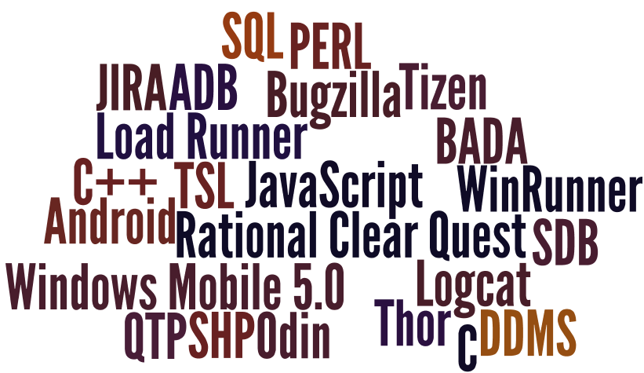
Testing: Mobile Applications Testing
Language: C, C++, TSL
Tools: JIRA, Rational Clear Quest & Bugzilla, ADB, SDB, DDMS, Logcat, Thor, Odin
Mobile OS: Tizen, Android, BADA, SHP & Windows Mobile 5.0
Scripting Languages: JavaScript & PERL
Exposure: Data Structures, SQL, WinRunner, QTP & Load Runner

ORGANIZATIONAL EXPERIENCE
Jun'09 - till date: SAMSUNG R&D Institute India, Bangalore (Formerly SISO)

The Growth Path
Jun’09 – Mar’11 Senior Software Engineer-2
Apr’11 – Feb’13 Lead Engineer
Mar’13 - till date Technical Lead

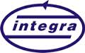
May'05 - May'09: Integra Micro Systems (P) Ltd., Bangalore, India
The Growth Path
May’05 – Jun’07 Software Engineer – Training
Jul’07 – May’09 Senior Software Engineer – Training

Key Result Areas

Software Testing & Team Management
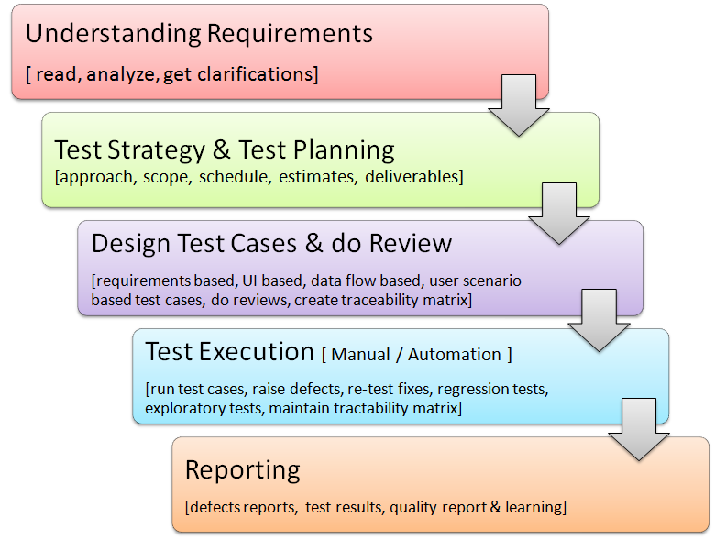
- Interacting with clients for requirement gathering, system study & analysis, documenting g, tracking, communicating bugs, enhancements, analysis and unresolved problems
- Accountable for managing the complete end-to-end process for user acceptance testing phases of the project and executing testing within deadlines.
- Creating test plan & test cases and conducting functional, smoke & regression testing of the application
- Preparing detailed QA test plan including the scope, objectives, focus, resources, etc. of the testing effort.
- Handling a testing team of 12 members involved in regularly reporting the status of testing progress.

Software Training
- Conducting & coordinating training sessions, developing & reviewing the training material, conducting pre & post session quizzes and mentoring & evaluating the trainees.

Major Projects
@SAMSUNG @Integra

- Browser Application Testing (Tizen, Android, Bada & SHP)
- Cloud-Sync Testing of Browser App. Testing (Android)
- WRT-WAC2.0 API Testing (Android ICS)
- Push-To-Talk Client App. Testing (Windows 5.0)
- Training projects: PC-Sync Server & WAP-IM

Significant Accomplishments

@SAMSUNG
- Implemented special methods to prevent the bugs / defects from occurring in the first place
- Identified and detected bugs in very initial stage and took corrective action which minimized the bugs
- Bagged the Super Saver Award [Team Level] in 2009
- Member, ERT (Emergency Response Team )
- Certified ‘Life Saver’.

@Integra
- Accredited with Star Integran Award [Individual] in 2008
- Involved in training the employees as part of ‘Re-engineering’ program.

PREVIOUS EXPERIENCE
Sep’01 –May’05: St. Mary’s P.G. College, Hyderabad, India as Faculty

ACADEMIC DETAILS
- Master of Computer Applications from Osmania University, Hyderabad, Andhra Pradesh in 2001
- B.Sc. from Kakatiya University, Warangal in 1998

PERSONAL DETAILS
Date of Birth: 23rd November, 1976
Languages Known: English, Hindi, Telugu and Kannada
Permanent Address: H.No.14-122 (Revised), 14-105 (Old), Dharmapuri, Karimnagar – 505425, Andhra Pradesh
Passport number: Z2448140
PAN: AEAPV0594A

ANNEXURE

Project: # Mobile Browser Application
Client: Samsung Electronics Co., Ltd., South Korea
Summary: Mobile Browser (also called a micro-browser or mini- browser) is a web browser designed for the use on a mobile device such as a mobile phone or PDA. Mobile browsers are optimized so as to display web content most effectively for small screens on portable devices. The basic intent is to give the end-user a desktop browsing experience.
Features: Page preview & normal mode, landscape & portrait mode, history, bookmarks, settings, zoom in and zoom out, save image, save web page, saved pages, desktop view and mobile view, RSS feeds, reader, filter images/i-View, support for AJAX, JavaScript and CSS, URL auto complete, upload contents, direct download, OMA download, DRM and OMA OTA, password manager, cloud-sync.
Role: Test Lead

Project: # WRT-WAC2.0 API
Client: Samsung Electronics Co., Ltd., South Korea
Summary: The Wholesale Applications Community (WAC) is an organization that was set up to create an unified and open platform to allow mobile software developers to more easily write applications usable on a variety of devices, operating systems and networks. OneAPI is a global GSMA initiative to provide application programming interfaces (APIs) that enable applications to exploit mobile network capabilities, such as messaging, authentication, payments and location-finding with a cross-operator reach. For example, a messaging network API could be used to enable an app to send an SMS message to another device, while a payment network API could be used to add an in-app purchase to the user’s mobile phone bill.
Role: Lead Engineer
KRA: Successfully developed & executed test cases for the Webview API. Tested other APIs including Accelerometer, Calendar, Camera, Contacts, Device Interaction, Device Status, File System, Geolocation, Messaging, Orientation, Tasks and Viewport.

Project: # XPW Windows Mobile App
Client: Sonim Technologies, San Mateo, California, USA
Summary: Push-To-Talk over Cellular (PoC) client is a Mobile Windows application. PoC service is a two-way form of communication that allows users to engage in immediate communication with one or more users. PoC service is similar to a “walkie-talkie” application where a user presses a button to talk with an individual user (1-to-1 call) or broad cast to a group of participants (one-to-many call). The communication is a half-duplex communication, i.e. at most one person can talk at a time and all other participants can here the speech. Modules of the PoC client application include: Contacts, Groups, Call logs, DVM, Settings.
Role: Senior Test Engineer

Project: # PC Sync Server
Client: Jataayu Software, Bangalore
Summary: The PCSync server is a PC side server application which synchronizes the data between the server and its mobile client over the network. It can also be used for peer-to-peer data synchronization. The data synchronization can happen between the server and client in any of the below seven synchronization methods.
Features: Two-way sync. slow sync. One-way sync. from client, one-way sync. from server, refresh sync. from client and server alerted sync.
Role: Training & Test Engineer

